TITLE OF YOUR EXTENDED ABSTRACT (TNR, Bold 14pt centered)

Author, A¹, Author, B², and Author, C³ (TNR 12pt centered)

¹Institution 1(TNR 12pt centered)
²Institution 2 (TNR 12pt centered)
³Institution 3 (TNR 12pt centered)

E-mail (First author)
Phone: (First author)
Shipping Address: (First author)

Participants in the Armand Blanc competition are requested to submit an extended abstract not exceeding four (4) pages in English, not including references.
The extended abstract must include the title, author(s) introduction, material and methods, results and discussion, conclusions, and references. The manuscript should be prepared on a letter-sized paper with 1-inch margins on all sides and typed with single spacing using size 12 Times New Roman font (TNR). All illustrations (figures, equations, tables, etc.) must be prepared inside of the main text.

- INTRODUCTION (headlines: TNR Bold, 12pt)
Provide the necessary background to the research/development including relevant literature, it’s objectives and importance.

- MATERIALS AND METHODS (headlines: TNR, Bold, 12pt)

The methodology must be clearly stated and described in sufficient detail or with sufficient references.

- RESULTS AND DISCUSSION (headlines: TNR Bold, 12pt)
The findings and arguments of the work should be explicitly described and illustrated. All the tables, images and figures should be centered. Figures and images should be numbered and figure headers should be placed under the figure or image; as for the tables, they should also be numbered and the table header should be placed at the top. References (if any) of the tables, figures and images should be presented right under the tables, figures and images in the form of author surname and publication date.

- TEXT COMPONENTS (headlines: TNR Bold, 12pt)

4.1 Equations
Equations should be centered and numbered consecutively, as in Eq. [1]. An alternative method is given in Eq. [2] for long sets of equations where only one referencing equation number is wanted.
(1 line spacing here)

 |  | [1]
where, | (1 line spacing here)
 |  | [2]

  - List
Lists can be provided using either numbers or bullets:
- List item 1 like this.
- List item 2 is an example of a longer list item that wraps to a second line, where the second line is indented.
The example for bulleted items like this:
- List item 1;
- List item 2.

  - Tables and figures
Tables and figures should appear in one column of a page and be numbered consecutively. Figures and texts may appear on the same page, and a centered caption should appear directly beneath the figure. It is preferable that figures be mounted in portrait style and figure captions are no longer than two lines. On figures showing graphs, both axes must be clearly labeled (including units if applicable).
Tables should be designed to have a uniform style throughout the paper, following the style shown in Table 1. Table captions should be in 10pt “Time News Roman” bold, centered, and the texts in Table should be set in 9pt “Time News Roman” font.

Table 1. Caption heading for a table should be placed at the top of the table and within table width.
(Use “time news roman” font, size 10pt, No spacing after table title)
 | A | B | C | D
A | Aa | Ab | Ac | Ad
B | Ba | Bb | Bc | Bd
C | Ca | Cb | Cc | Cd
D | Da | Db | Dc | Dd
E | Ea | Eb | Ec | Ed

Authors are advised to prepare their figures in either black and white or color. Please prepare the figures in high resolution (300 dpi) for half-tone illustrations or images. Pictures must be sharp enough otherwise they will be rejected. Figures must be originals, computer-generated or drafted, and placed within the text area where they are discussed. Figure 1 shows an example. Figure captions should be in 10pt TNR font, bold, centered. When applicable, the texts in graphs, illustrations or images should be set in 8pt TNR font.
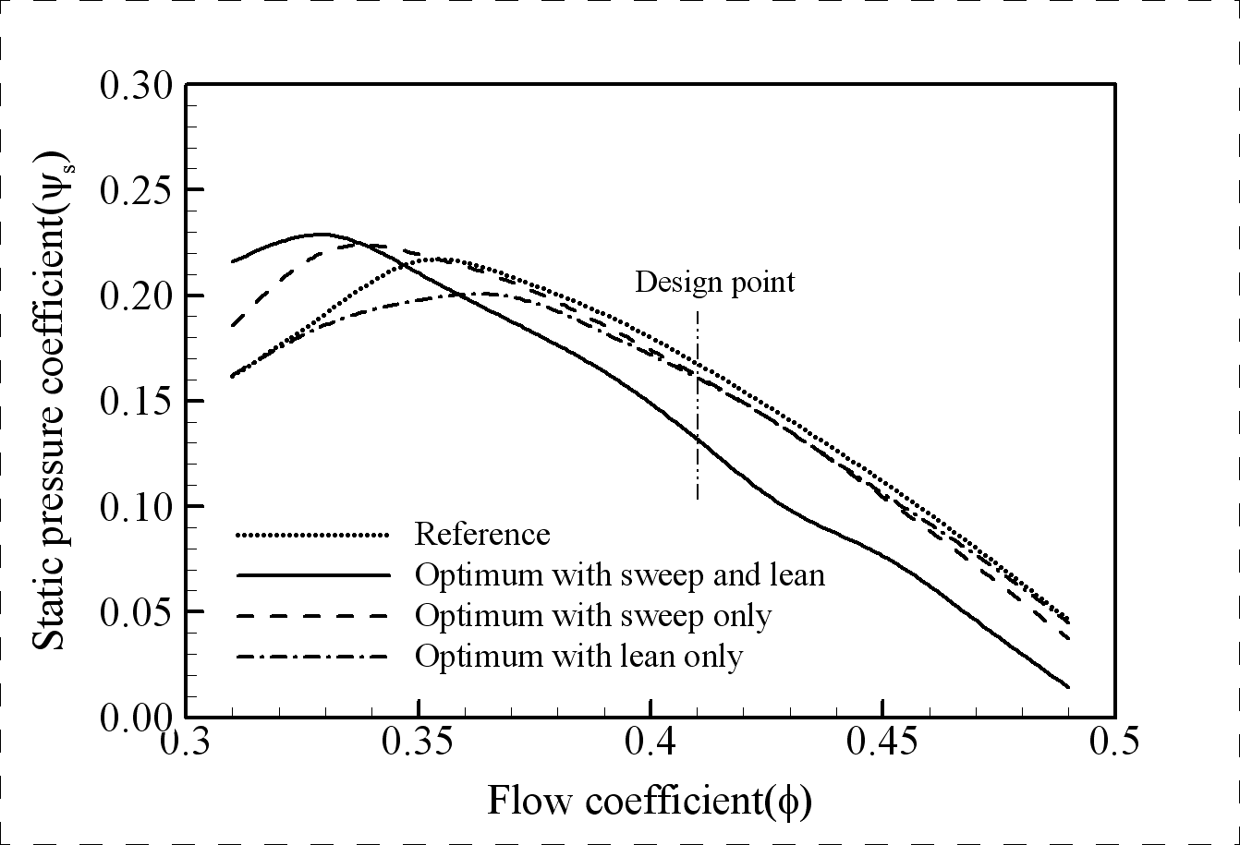
Figure 1. The caption heading for a figure should be placed below the figure and within figure/illustration width. (Use “Time News Roman” font, size 10pt, no spacing between title and figure)

  - Footnotes
Footnotes are denoted by a character superscript in the text b.

  - Units
Use either SI (MKS) as primary units. English or CGS units may be used as secondary units (in parentheses). Avoid combining SI and CGS units. This often leads to confusion because equations do not balance dimensionally. If you must use mixed units, clearly state the units for each quantity that you use in an equation. Do not mix complete spellings and abbreviations of units. Spell out units when they appear in text.

- CONCLUSION (headlines: TNR Bold, 12pt)
Conclusions should include (1) the principles and generalizations inferred from the results, (2) any exceptions to, or problems with these principles and generalizations, (3) theoretical and/or practical implications of the work, and (5) conclusions drawn and recommendations.

- ACKNOWLEDGMENTS (headlines: TNR Bold, 12pt)
The authors would like to express appreciation for the support of the sponsors [Project Number = XXXXXXX].

- REFERENCES (headlines: TNR Bold, 12pt)

References should be listed arranged in alphabetical order beginning with the author’s names and initials, followed by the year of publication, title of periodical, volume and page. Example:

Parlange, J.Y., R. Haverkamp and J. Touma. 1985. Infiltration under ponded condition: 1. Optimal analytical solution and comparison with experimental observation. Soil Sci., 139: 305-311.
In the text, references should be cited with the name of the author(s) with the year of publication in parenthesis, e.g., Philip (1957), Taylor and Baker (1986), Smith et al. (1987).

b Just like this one.

